 | Hkkjrh; izksS|ksfxdh laLFkku xqokgkVh  Indian Institute of Technology Guwahati  Guwahati 781 039, India

Chairman, Students’ Welfare Board

 | Name | Period
 | Name | From | To
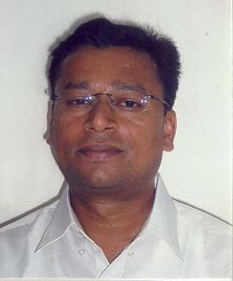 | Dr. S. R. M. Prassanna, ECE | 4/1/2007 | 3/1/2009
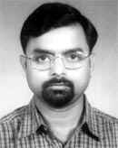 | Prof. D. C. Dalal,  Mathematics | 19/6/2009 | Till Date

